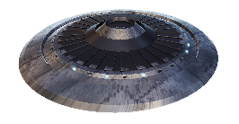**CSCI3260, Term 1 2022-2023, Course Project**

**SpaceAngel**

Student: Timothy Chung Yiu Ting & Wong Tak Kai

SID: 1155111158, 1155126532

**======================== Introduction =============================**

This is a space fighting game which you can shoot to kill UFO to protect the safe of earth.

You will have a health bar to indicate your health, once it is zero you will dead and reset.

Also there will be a energy bar for you to perform dash movement

**===================== Movement Control ==========================**

**↑,↓ Key / W,S key:**

Move the spacecraft forward or backward by where the it face at.

**←,→ Key / A,D key:**

Move the spacecraft to left or right side

**Space / Left SHIFT Key:**

Move the spacecraft upward or downward

**Mouse cursor movement:**

To rotate your spacecraft direction and adjust camera viewing angle

**F key:**

Dash movement to forward and kill UFO within the moving distance (Has cooldown, shown by blue energy bar)

**Mouse Left Click:**

Hold to use weapon and fire bullet to kill UFO

**===================== Setting Control ==========================**

**Esc key:**

Pause the game and open menu

**R key:**

Reset the game

**1,2 key:**

Select your spacecraft skin

**T / G Key:**

Increase or decrease the LED light intensity

**Y / U Key:**

Increase or decrease the ambient light intensity

**H / J Key:**

Increase or decrease the Sun light intensity

**, / . Key:**

Increase or decrease the mouse cursor movement sensitivity

**===================== Overall ==========================**

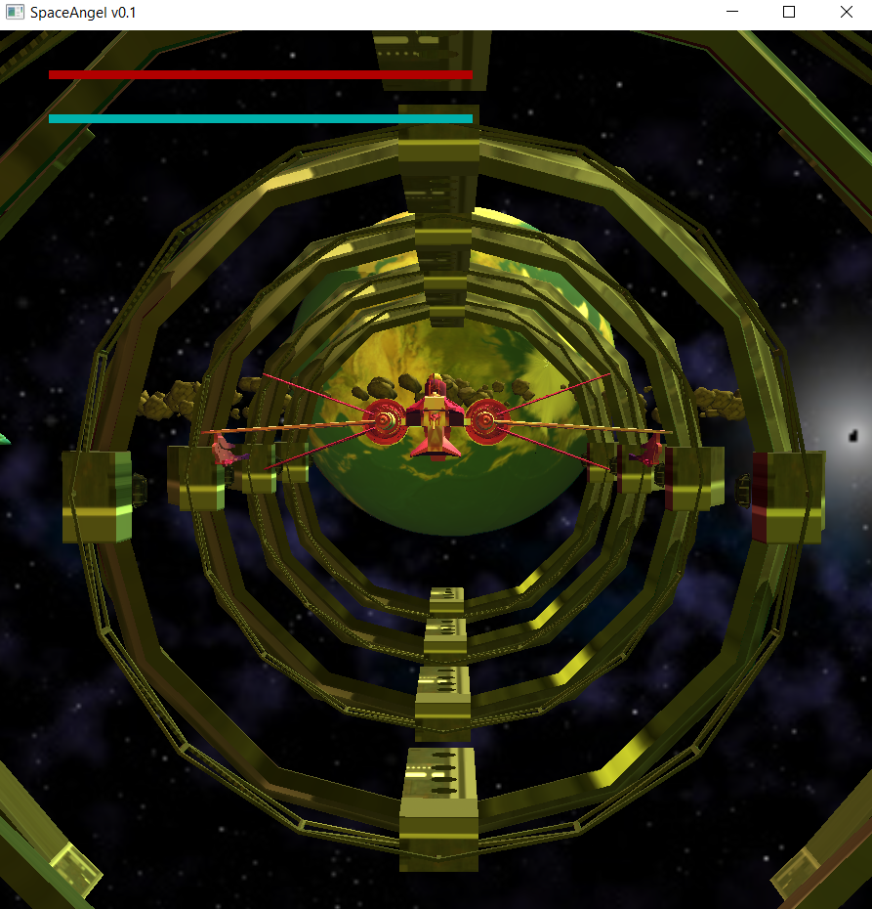

Starting screen: There are one planet, one spacecraft in the docking bay and some random generated space vehicles in the skybox. And all of them will self-rotate.

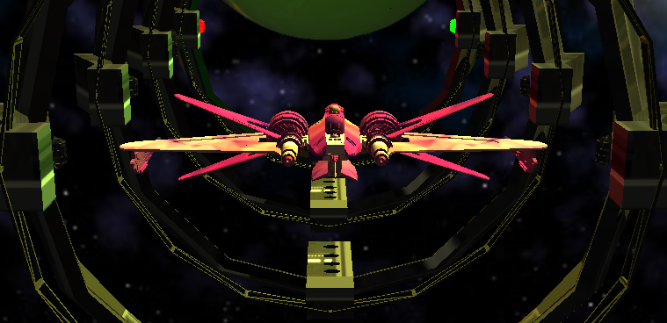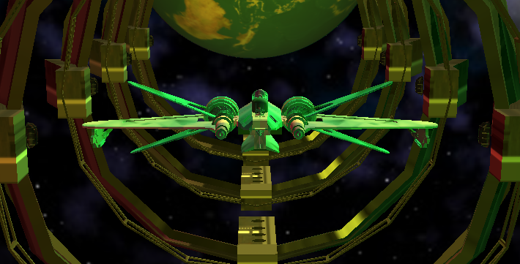

Press 1 or 2 key to change your space craft skin

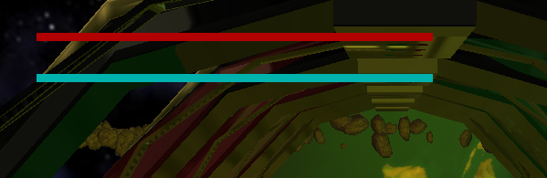

Health bar and Energy bar are show on the top left of the screen

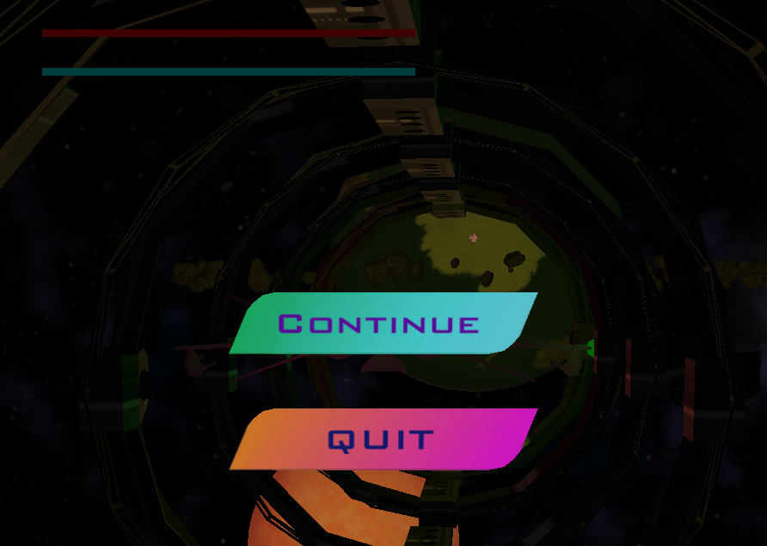 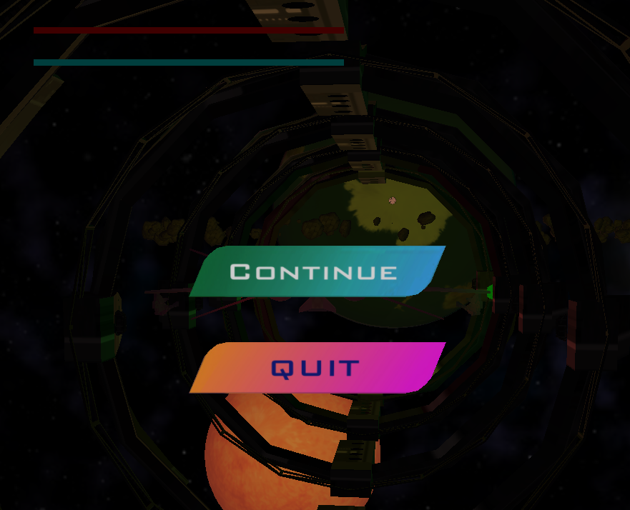

Esc to pause the game and open the pause menu, if you move your mouse to the button, there will have a hover event on the button.

**===================== BONUS FEATURES =======================**

**===================== Light condition ==========================**

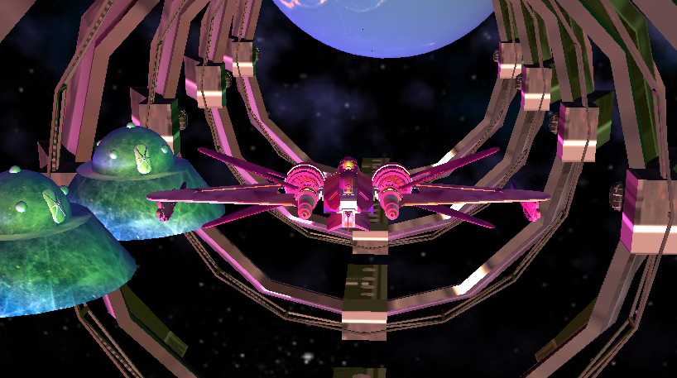

For basic requirements, you can see different light source with (ambient, diffuse and specular) are rendered to all objects, you can see each object have different colour.

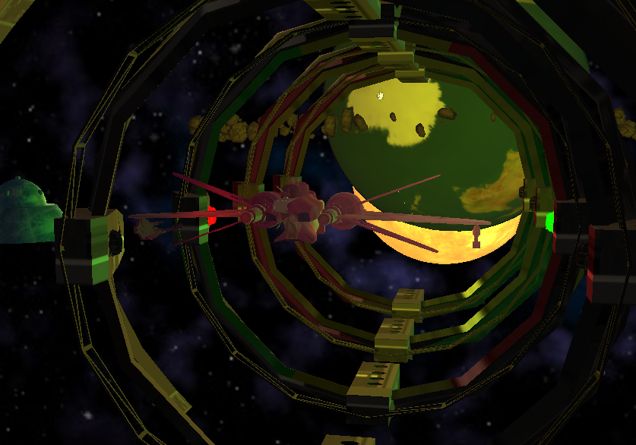

In the ship dock you can see two LED light with red and green colour, which themselves will emit different colour of light and the LED object itself have emission on its surface. Use T,G Key to adjust the intensity of the LED light.

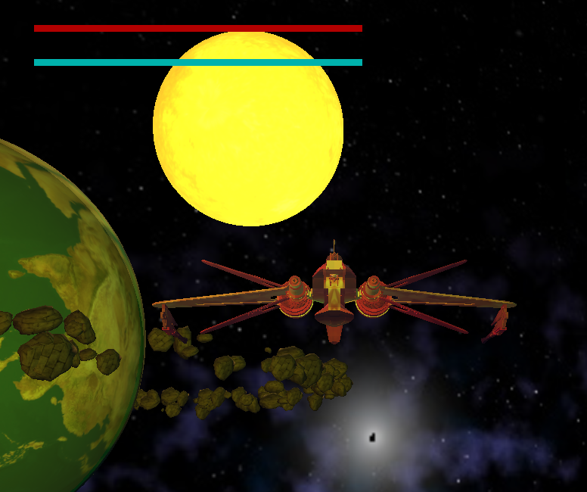 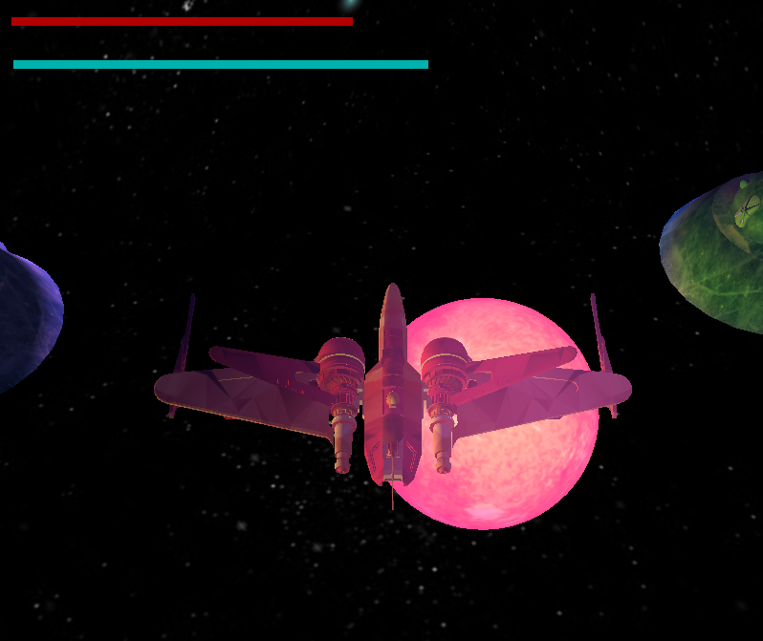

In the screen there are also a sun will emit lights and rotate around the spacecraft, the emission light colour of the sun will change overtime. Use H, J Key to adjust the intensity of the LED light.

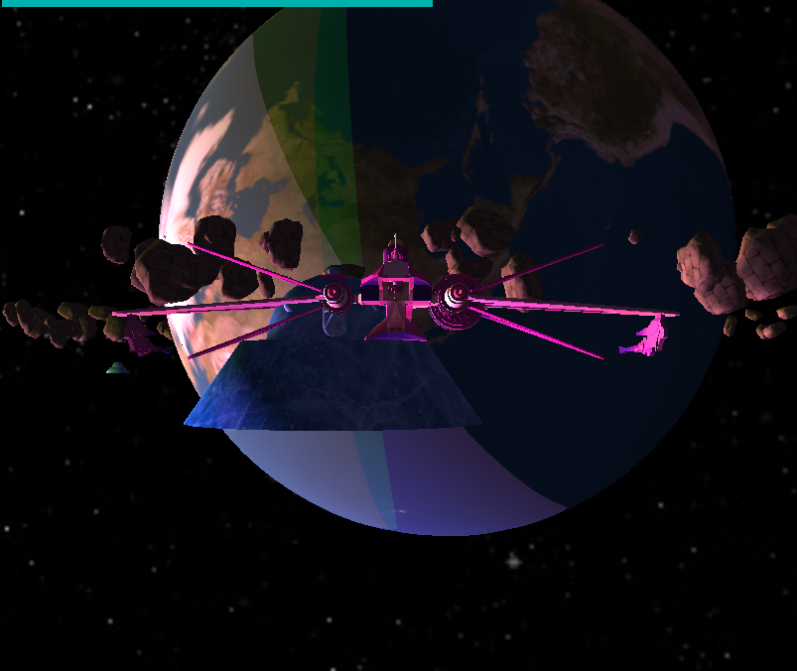

You can see how the sun light is projected on the earth.

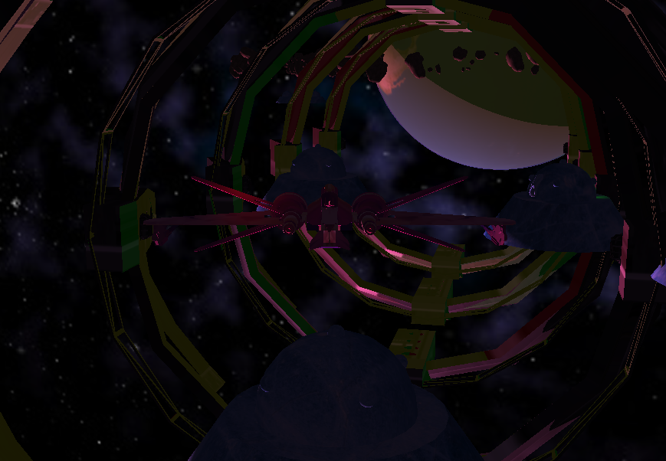 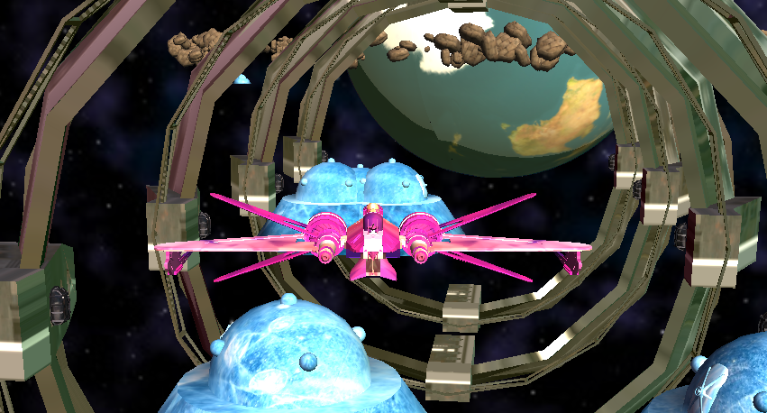

Also, ambient light intensity can be adjust by Y, U key, you can see the different of intensity.

**===================== Attacking ==========================**

**There are 2 main ways to attack:**

1. **Press F to Dash into an enemy to kill**
2. **Hold Left Click to shoot bullets**

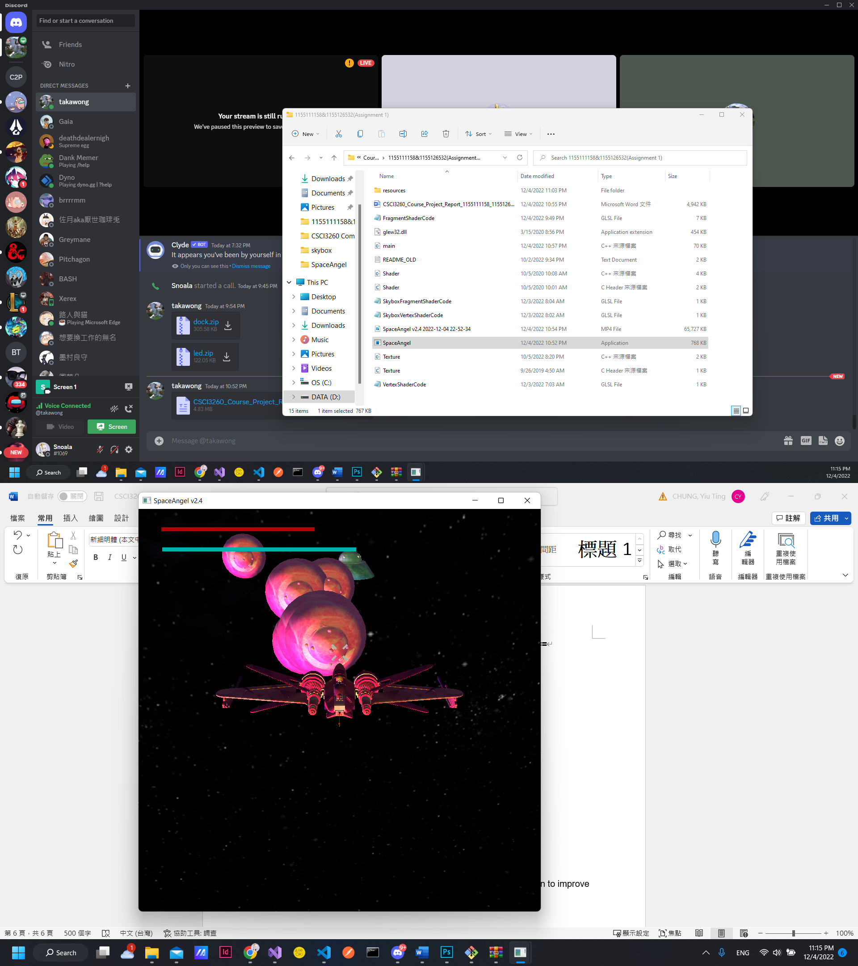

**Dashing** moves the spacecraft forward a distance in a quick speed, killing all enemies in the way, while also providing **temporary immunity** to the player.

This however **depletes the blue Energy** bar and therefore **cannot be infinitely spammed**.

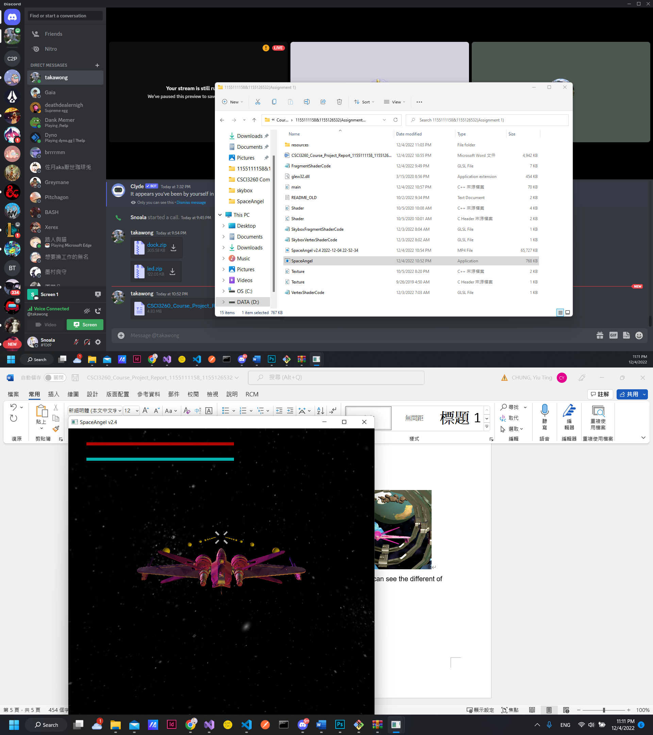

Holding Left-Click **shoots bullets** and can also kill enemies, while not providing invincibility to the user.

In the most recent update, a white target cross is anchored on the screen to improve the aiming system.

**===================== Enemy AI ==========================**

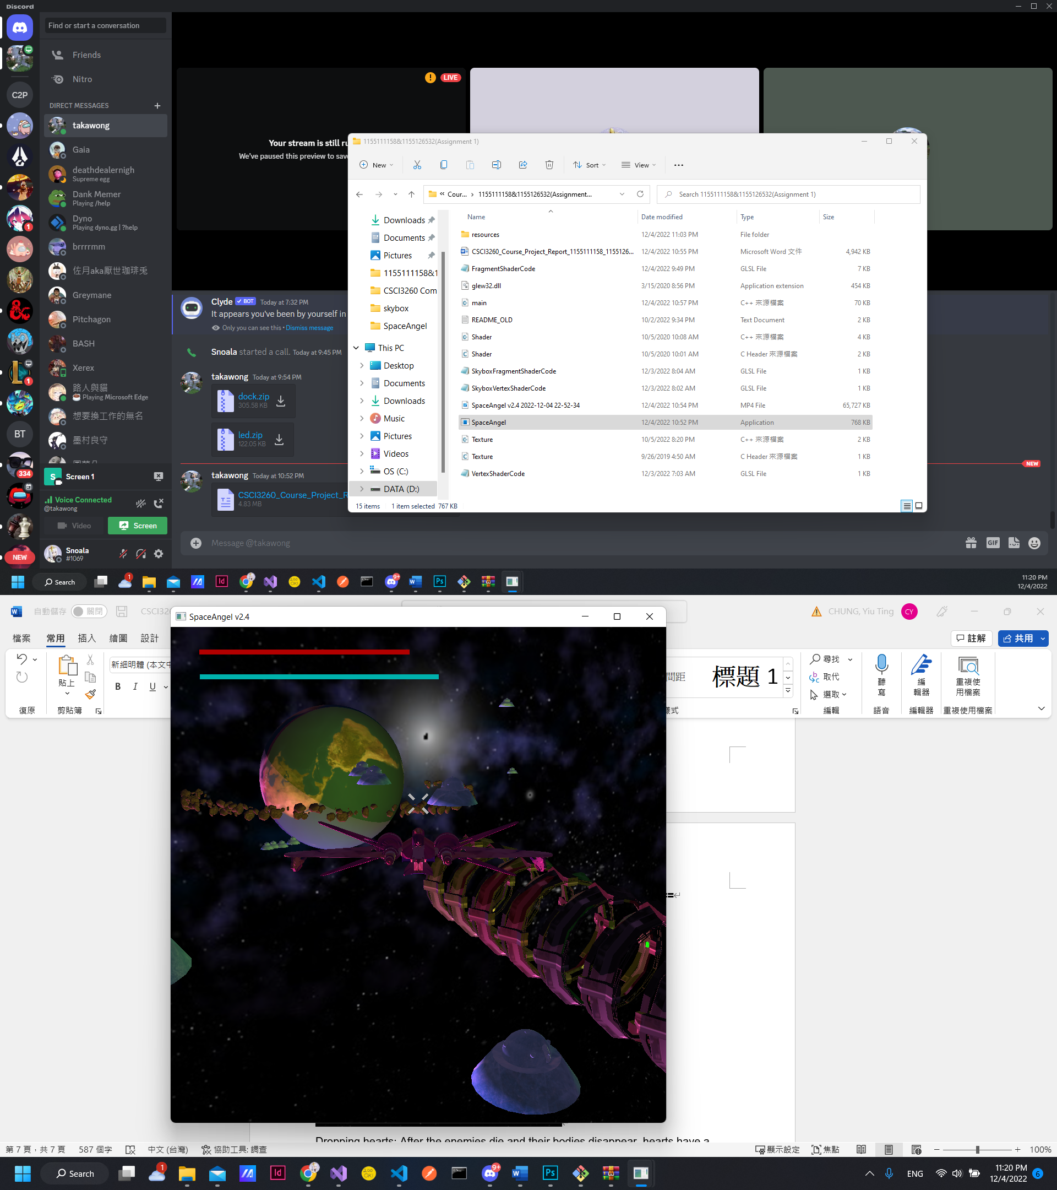

**Spawning:** The positions of where enemies spawn is totally random, but restricted to being in the volume of a hollow sphere around the player, making sure they are neither too far are too close to the player.

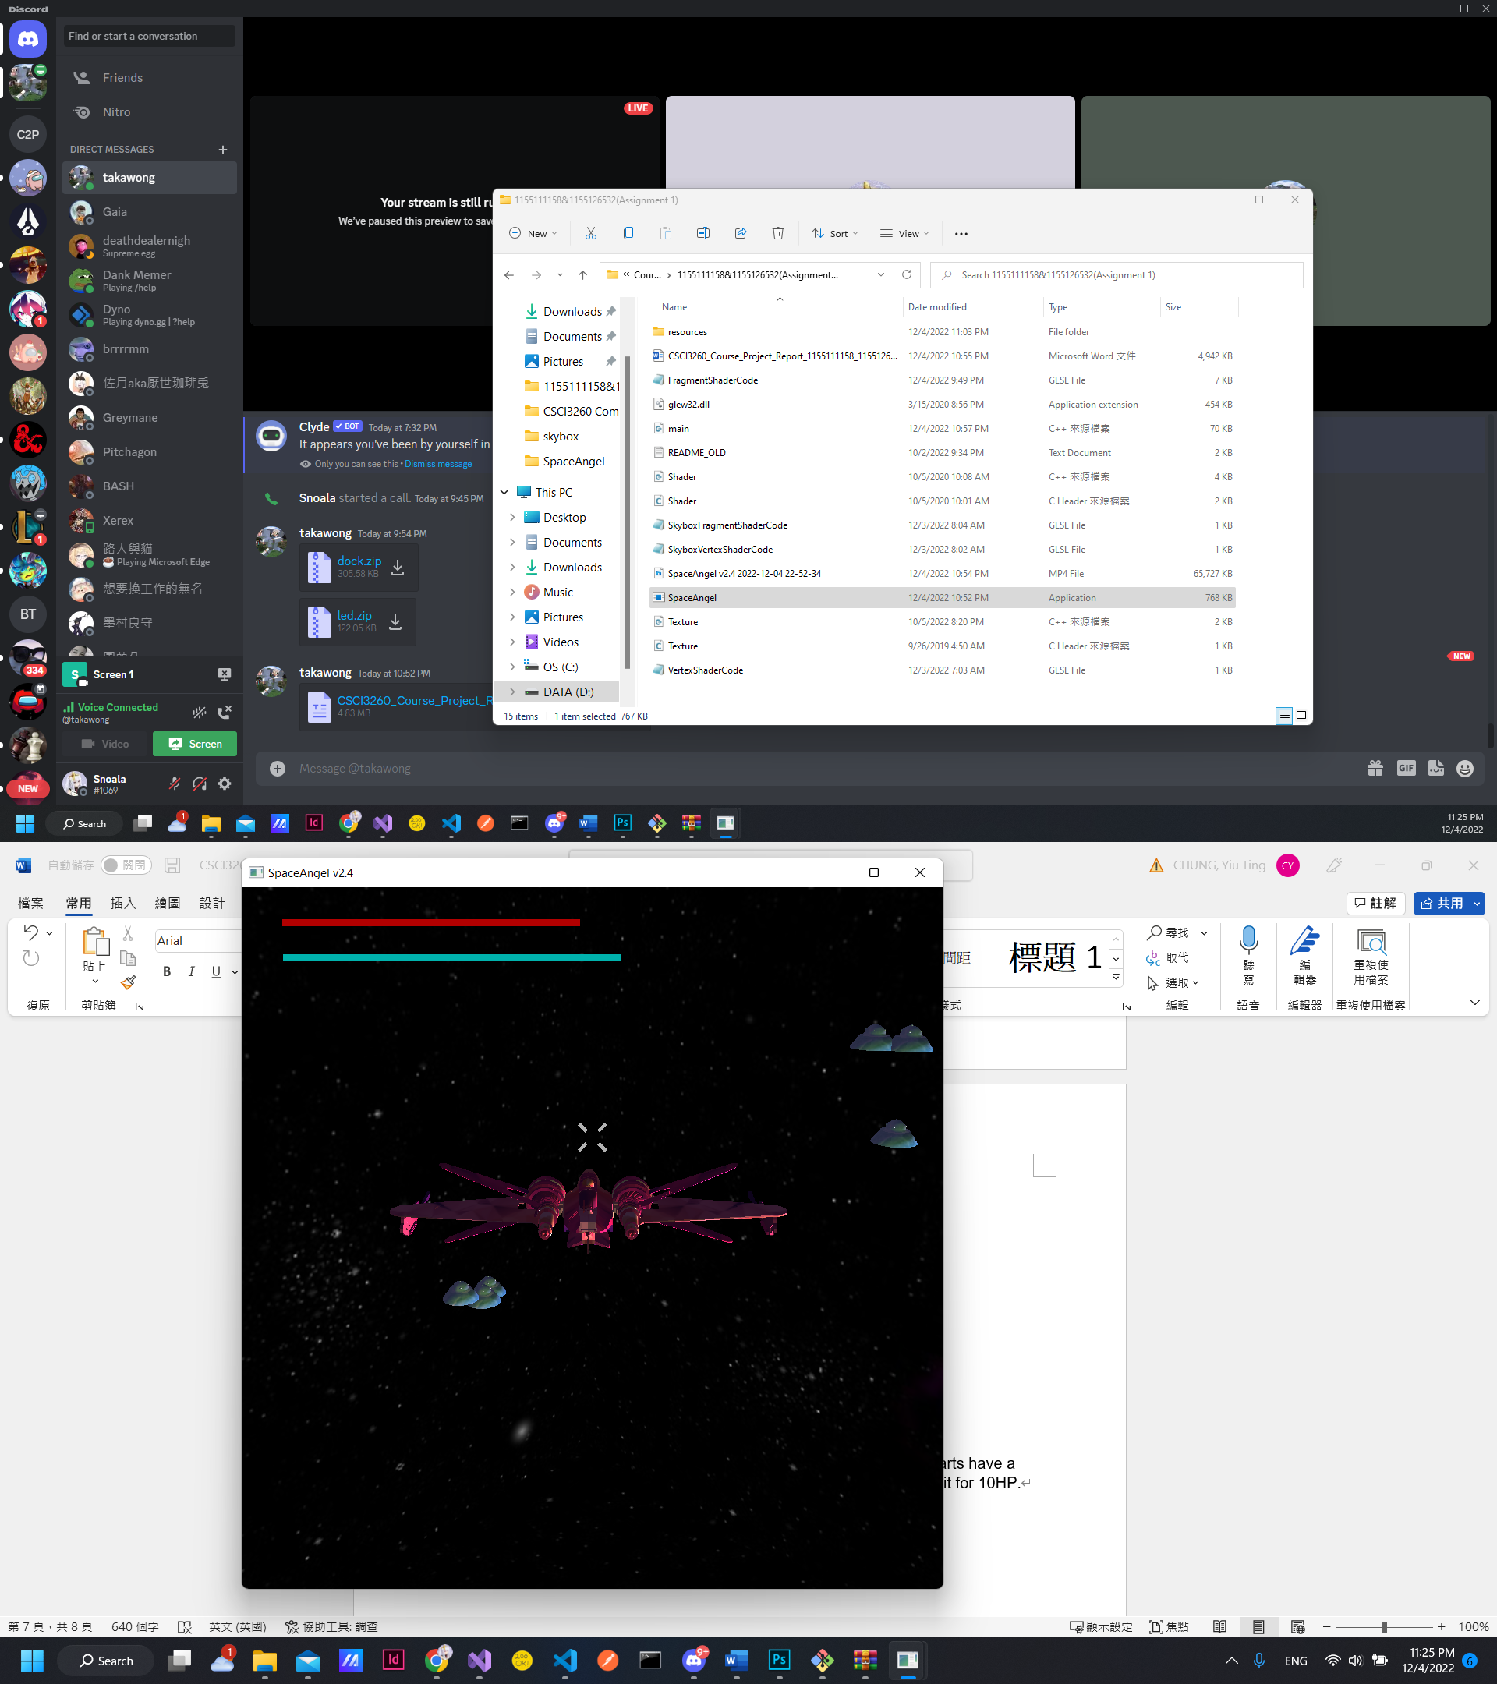

When the enemies can detect the player (close enough to) they crowd to travel towards the player to **prepare an attack**.

Some enemies are **cowardly enemies** and try to run away instead!

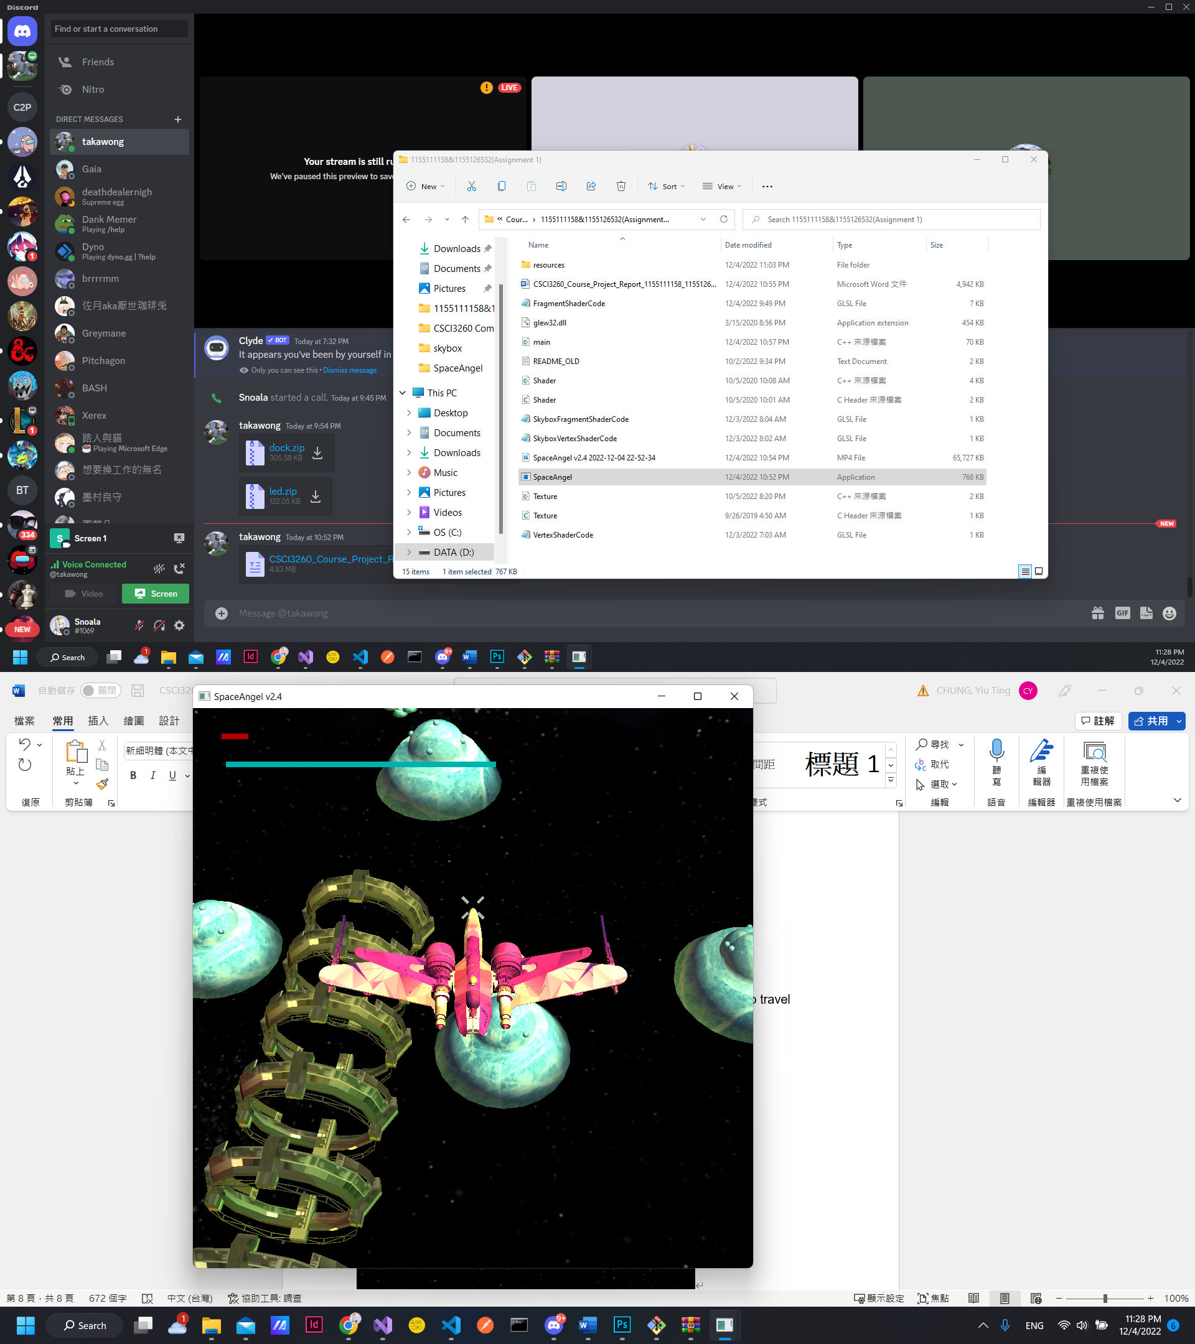

When close enough to the spacecraft, enemies **dash** into the player as an attack, dealing **3HP per contact** with the player.

Meanwhile, **cowardly enemies** **dash away, unable to deal any damage**.



**Dying:** As the enemies get lethal damage, they change texture and orientation for 5 seconds before disappearing.

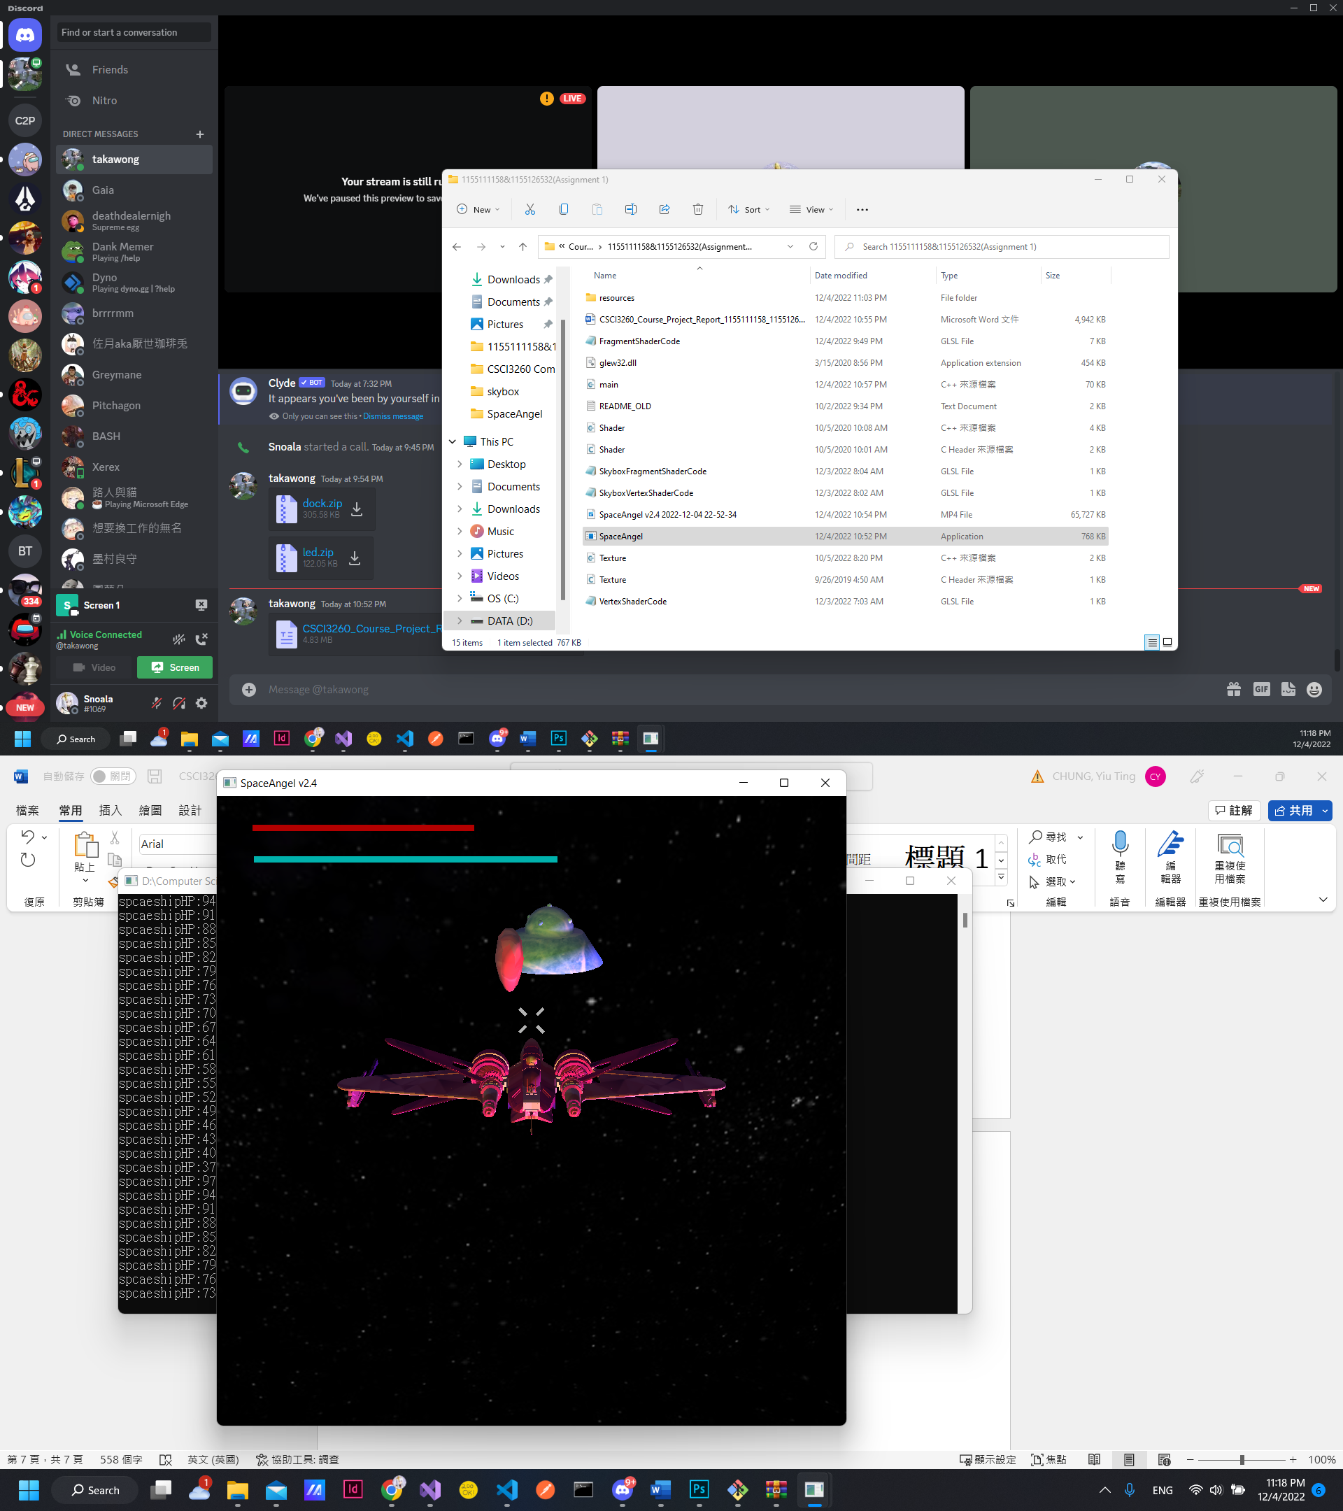

**Dropping hearts:** After the enemies die and their bodies disappear, hearts have a 20% chance of showing up which heals player if the player collides with it for 10HP.

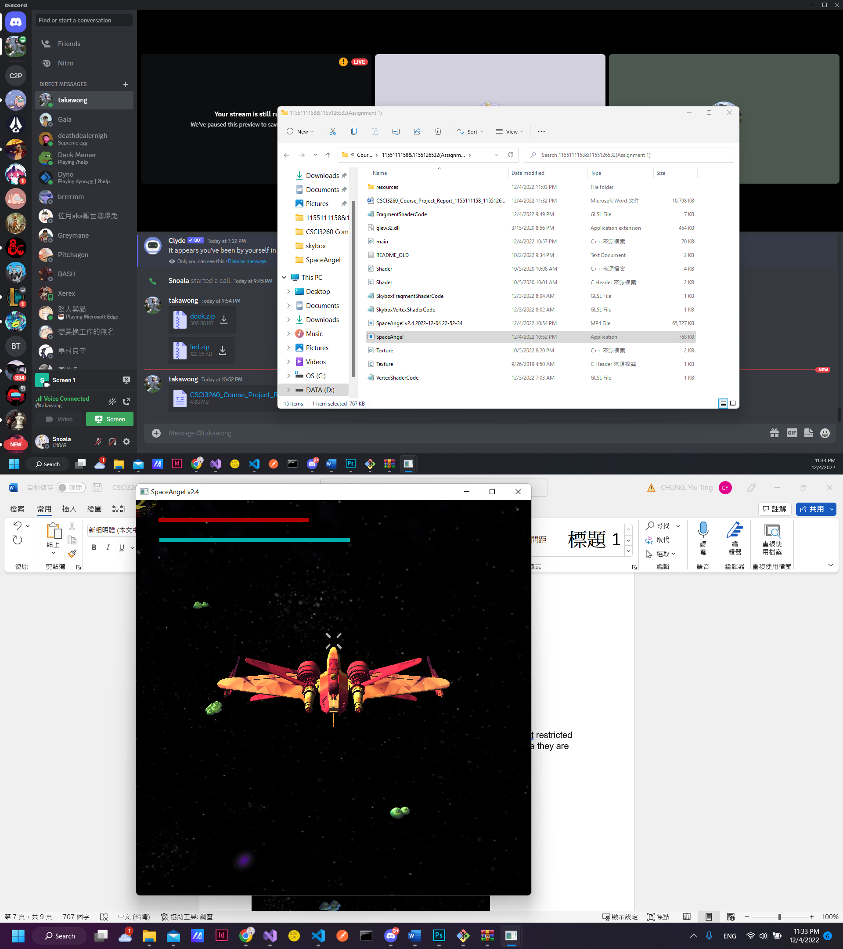

**Spawn Waves:** As the number of enemies die, the game keep tracks of how many enemies are alive at the same time. If there are too few, new enemies will be spawned in.

As time goes on, the limit for number of enemies goes higher and higher, for 10 more enemies per 30 seconds in the game.